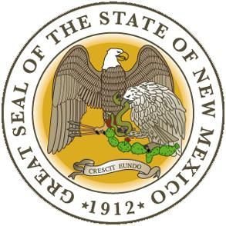
New Mexico Higher Education Department
Dyanne Salazar, High School Equivalency (HSE) Administrator
2044 Galisteo Street Suite 4
Santa Fe, NM 87505
HSE Test Voucher Application
First Name: ___________________________MI:_____ Last Name: ________________________________________
Address: ________________________________________________________________________________________
City: ___________________________________________________ State: ____________ Zip Code: ______________
Phone Number: ______________________________ Alternate Phone Number: ______________________________
Email Address: _______________________________________________ Date of Birth: ________________________
Information above MUST be correct to receive the voucher. Voucher information will be sent to the email address listed.
Which test are you requesting a free testing voucher for? CHECK ONE:
Educational Testing Service (HiSET®) ___or Pearson Vue (GED®) ____ For more information about both tests click here
If you are age 16-18: You can test remotely however, you need to send the Underage Permission Form along with the voucher to the New Mexico Higher Education Department . English and Spanish versions of the Underage Permission Form can be found here: English Version Spanish Version
For a complete list of Test Center locations and contact information click here
Do you want a voucher to take the HSE test in person at an approved testing center, or remotely (i.e. on your own computer at home)? If remotely, you are responsible for remote proctoring fees. ($17.00 per module)
CHECK ONE: Remote Proctoring* _______ or Approved Testing Center ______
*If you choose the Remote Proctoring option, you must attach a copy of your VALID STATE ID to receive a voucher.
Regardless of age: To be eligible to receive a voucher, you will need to take an Official Practice Test for the HiSET® or GED®. Scores must demonstrate test readiness according to test publisher guidelines.
Sign and submit this form with all necessary documentation to: dyanne.salazar@state.nm.us. If you have questions, you can call Dyanne Salazar directly at 505-269-3074
I verify that all information above is correct: ________________________________________________________
Student Signature + Date
APPLICANT: PLEASE FILL IN OFFICIAL PRACTICE TEST SCORES BELOW & ATTACH COPY OF SCORE REPORT TO VERIFY
Which Official Practice Test did you take? ⃝ GED® or ⃝ HiSET® Official Practice Test Scores:

Writing Score |  | Language Arts |  | Math |  | Social Studies |  | Science
(HiSET® only) |  | Score |  | Score |  | Score |  | Score
I approve the student listed above to receive a voucher to take the HSE exam:
HSE State Administrator Signature Date

