How do I register for a site?

- How to Register
- Required Information
- Registration Errors

How to Register
If registration is open to the public:
- Click Register
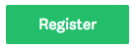
- Choose to Register using a Social Media Account (Facebook, Google, Twitter)
OR
Choose to Register to SurveyMonkey Apply
- Selecting a Social Media Account redirects to that platform to complete your registration
Selecting to register to SurveyMonkey Apply directs to the SM Apply Registration page.
- Click Create Account
NOTE: If you can't see the Registration button, Registration may be closed by the administrators.

Required Information
- First Name
- Last Name
- Email
- Password/Confirm Password
- Any extra required information as set by the administrator
- Complete the Captcha
For clarification on registration requirements, we recommend reaching out to the site administrators.

Registration Errors
Here are potential errors you could experience while registering:
Missing Required Information
To register for the site, complete all required fields within the registration form. If you have difficulty registering, check for this warning in regards to a missing field:
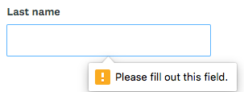
Account Already Exists
When you register or are invited to a SurveyMonkey Apply site, an account gets created for you within the SM Apply database. Once registered within one site you will need to re-register using the same password and credentials as the existing account.
If this is the case, then a message appears that "An account with this email already exists." You will then be prompted to:
- Register with a new account
- Reset your password
- Complete the registration with that account
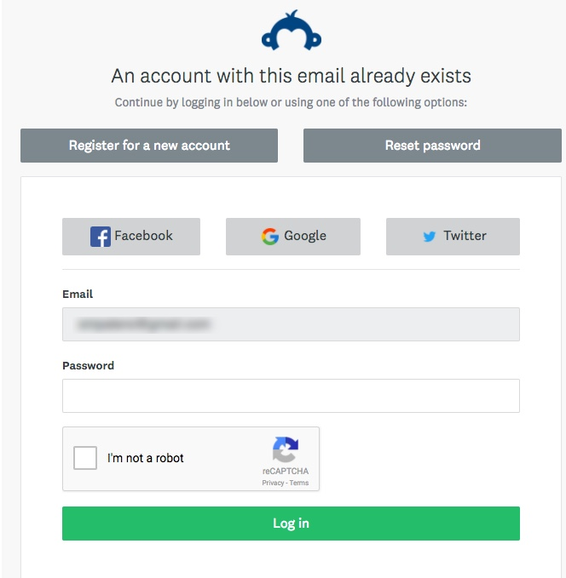

How do I reset my password?
If you forgot your password and aren't able to login you can reset your password through email.
To reset your password:
- Go to the Homepage of the site you're trying to access
- Click Log In
- Underneath the Email/Password fields, click "Forgot your password?"
- Enter the email address that you use to login to the site
- Click Send Instructions
- You will be sent instructions to the email you entered to reset your password.
NOTE: If you aren't to locate the email in your inbox, we recommend checking your Spam/Junk folder
- Click on the link within the email
- Enter a new password and confirm the password
- Click Reset Password

Your password must contain at least:
- 8 characters (including letters, numbers, and special characters)
- One uppercase letter
- One lowercase letter
- One number
- One special character (!@#$%^&* etc.)

I want to change my current password
If you wish to change your password on your account:
- Log in to your account
- Click on your Name in the top right corner of the page
- Select My Account
- Go to My Profile
- Enter your current password
- Enter your new password and Confirm your new password
- Click Save

How do I change my Name or Email address on my account?
If you wish to change your Name or Email address on your account:
- Log in to your account
- Click on your Name in the top right corner of the page
- Select My Account
- Go to My Profile
- Edit the Name and Email address
- Click Save
NOTE: You won't be able to change your account to another email that already has an existing account. Instead, you will need to log in to that account.

How do I change the timezone on my account?
If you wish to change your timezone on your account:
- Log into your account
- Click on your Name in the top right corner of the page
- Select My Account
- Go to My Profile
- Select the time zone that you're in.
- Click Save
Your Application Activity will be displayed in the time zone you select.

How do I change my preferred language on my account?
If you wish to change your preferred language within the site:
- Log into your account
- Click on your Name in the top right corner of the page
- Select My Account
- Go to My Profile
- Click the Preferred Language drop-down
- Select the language you wish to change to.
NOTE: The languages available are based on the configuration of the site by the administrators. For any information in regards to the languages available you can reach out to the administrative team.

How do I create a new application?
I haven't created an application yet
If you have no Applications created yet, within the site you can:
- Click View Programs
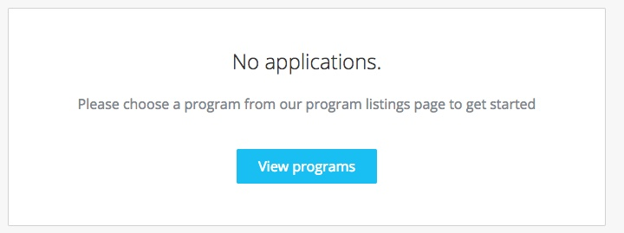
- You may need to complete an Eligibility Quiz if required by the site.
- Once you've completed the eligibility quiz, or if there is no quiz enabled, you will be able to View the programs.
- Click MORE > for the program you wish to apply for
- Click Apply
NOTE: Based on site configurations put in place by the administrators, you may not be able to create an application for a program. If you experience difficulties creating an application, you can reach out to the administrators of the site.

I have existing applications on the site
In the case where you've already created an application on the site and wish to create a new one:
- Click Programs in the top in the top right corner
- Click MORE > for the program you wish to apply for
- Click Apply
NOTE: Based on site configurations by the administrators, you may not be able to create more than one application. If you're experiencing difficulties creating more than one application, you can reach out to the administrators of the site.

How do I delete my application?
If you have started the application but no longer wish to continue, you can choose to Delete your application.
NOTE: You won't be able to delete a Submitted application. You will need to contact the administrators of the site for further help in regards to this.

There are two ways to Delete the application:
From the "My Applications" page
- Click on the More Options icon in the top right corner of the tile of the application you wish to Delete
- Select Delete
- You will receive the confirmation message "Are you sure you want to delete your application? You won't be able to undo this action"
- Click Yes to confirm

From Within the Application
If you're on the application page with the list of Tasks to complete, to Delete your application:
- Click on the More Options icon in the top right corner of the application.
- Select Delete
- You will receive the confirmation message "Are you sure you want to delete your application? You won't be able to undo this action"
- Click Yes to confirm

How do I submit my application?
To be able to submit your application you will first need to complete all required tasks within your application. Additionally, you will need to ensure that you've verified your email.
NOTE: A Banner will appear within your portal until you've verified your account. Click to Send Verification Link and follow the instructions sent in the email.
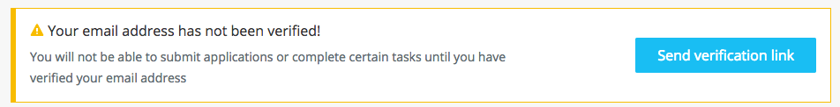
Once all tasks are complete, submit your application by performing the following steps:
- Within the application to submit, select Review & Submit
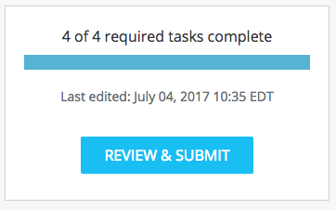
- Review application materials
- Once you've reviewed all your completed tasks, you can click to Submit Your Application.
- Choose to proceed back to your applications or View More Programs.

How do I preview my application?
There are two ways to Preview your application within the site:
From the My Applications Page
- Click on the More Options icon in the top right corner of the tile of the application you wish to Preview
- Select Preview

From Within the Application
If you're on the application page with the list of Tasks to complete, to preview your application:
- Click on the More Options icon in the top right corner of the application.
- Select Preview

Can I print/download my online application?
There are three ways to print/download your application within the site:
From the "My Applications" Page
- Click on the More Options icon in the top right corner of the tile of the application you wish to download
- Click Download
From Within the Application
If you're on the application page with the list of Tasks to complete, to download your application:
- Click on the More Options icon in the top right corner of the application.
- Click Download
From the Preview
- Within the Preview, click Download in the top right corner

Why can't I edit my task?
If your tasks Cannot be Modified or says The task cannot be started at this time, there are a few main reasons why this could occur.
- The deadline has passed
- Prerequisites haven't been met. Meaning you will need to complete other tasks before you're able to start this one.
- You've completed your task and the administrators don't wish for you to be able to make changes.
- Your application is locked.
Contact the administrator of the site if you aren't able to edit a task and wish to understand why.

I get an error when uploading a file
There are a few potential reasons why you may experience issues uploading your file:
- The file isn't in an available format.
Check to ensure that the file type you're trying to upload matches the requested formats.
- The file doesn't meet size restrictions.
Check to ensure that the file type you're trying to upload does not exceed the maximum file size of the upload task.
- You're attempting to Upload more files than allowed
Confirm that the number of files you're uploading is within the range of the minimum and the maximum number of files required.
- The file is encrypted
SurveyMonkey Apply won't accept encrypted files. To upload your file, it will need to be unencrypted.
- The file is corrupted
It is possible that the file you're trying to upload is a corrupted file. To resolve the issue, re-save the file to a new folder on your computer and attempt to upload the file again.
- A task related issue.
Depending on the issue it's also possible that the error is related to another Setting on the task. For example, you're unable to edit the task.

"WHOOPS! We Couldn't find what you were looking for."
If you're receiving this error warning, then the page you're attempting to access isn't available to you. This is based on restrictions on the site and is most likely related to not having permission to currently edit the task. For more information in regards to this you can refer to the section on Why can't I edit my task?

The deadline has passed, what can I do?
The administrators may set deadlines when they wish to restrict access to the application after that date.
As this is a configuration set by the administrators of the site you will need to contact them, for information on any process past a deadline.

Why is my application locked?
If your application appears locked within the site. It has either been locked manually by an administrator, or by an automation on the site.
Contact the administrator of the site if you wish to understand why your application is locked.

My Payment wasn't accepted/I was double charged, what do I do
If you experience an issue with completing a payment, we would recommend reaching out to the administrators of the site. If you've completed the payment, but, the task isn't being updated within the site, it means that the payment processor isn't notifying the SurveyMonkey Apply system to let us know that the payment has been processed.

The administrators will need to be contacted to confirm if they have received your payment and to potentially update any configurations within the payment processor, if necessary.

I submitted my application but didn't receive a confirmation email
A confirmation email is part of the configuration of the site set by the administrators. If you submit your application and haven't received an email, check your spam/junk folder. If you still aren't able to find the email, contact the administrators to confirm if one was sent.

You can also refer to I am not receiving any emails from the site for more information.

How do I Sign a Form?
If you're completing a form and it asks you to Sign the form:
- Click and Drag your mouse across the screen to draw your signature on to the form.

How do I change my Notification Preferences?
If you wish to change your notification preferences in the site:
- Log into your account
- Click on your Name in the top right corner of the page
- Select My Account
- Click Notifications
- Enable/Disable the emails you no longer wish to receive.
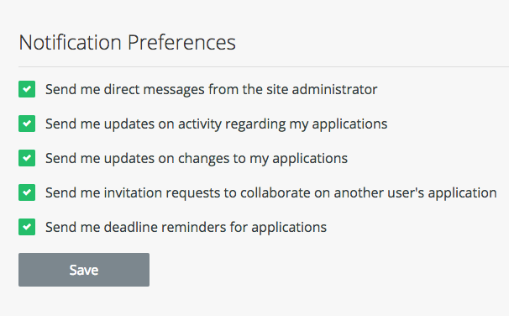

Why am I not receiving any emails from the site?
If you're currently not receiving any emails from the site:
- Ensure that noreply@smapply.io is added to your safe sender list within your email account.
- Ensure that your email is verified within the site. If you're receiving this notification at the top of your page, then it's possible that you won't receive other emails from the site.
- Ensure that you're subscribed to receive emails from the site.
- Check your Spam Folder to verify whether the email was sent to your Spam/Junk folder.
- Depending on the email(s) you're expecting to receive, reach out to the administrators to ensure that an email was sent out.

How do I contact the Administrators of the site?
The administrators are responsible for configuring SurveyMonkey Apply to suit their own needs. Any forms, deadlines, or emails are customized by them. So, they will be the best ones to answer many of your application process questions.
To contact the administrators of the site:
- Go to the Home Page or Log in to your Account
- Click on the Information (i) icon
- Click on Contact the Site Administrator
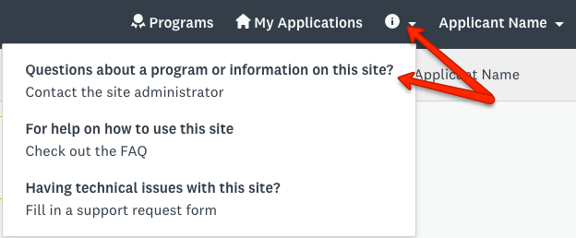
Your default email application will open for you to compose your email.

I have a technical issue with the software. Who do I contact?
Use this FAQ or contact the administrators of the site to confirm your issue is a technical issue. You can reach out to our helpful SM Apply Support team via Email to receive further help.
They will be able to provide help with troubleshooting your issue. Please provide as much information as possible, including attachments, links, and screenshots.
For more information on how to contact our Support team, you can refer to Email Support: For Applicants, Reviewers, and Recommenders

